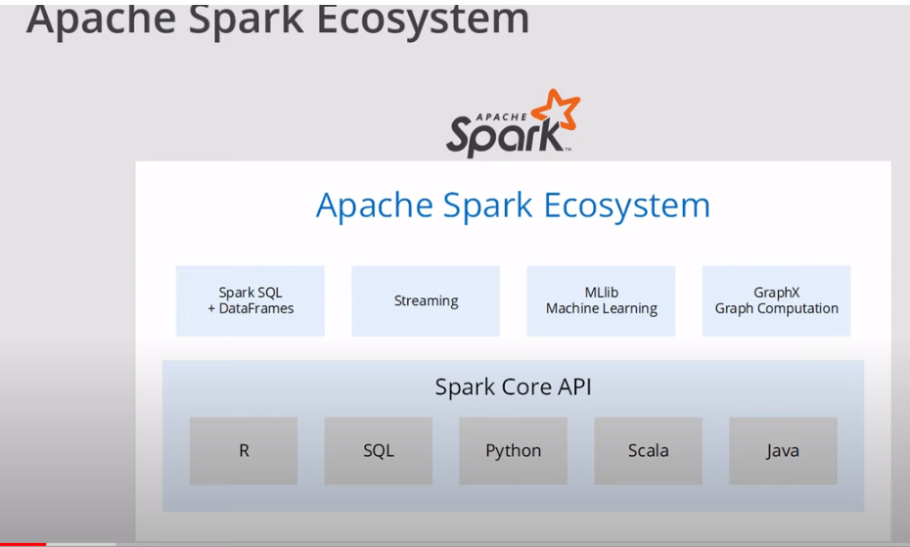

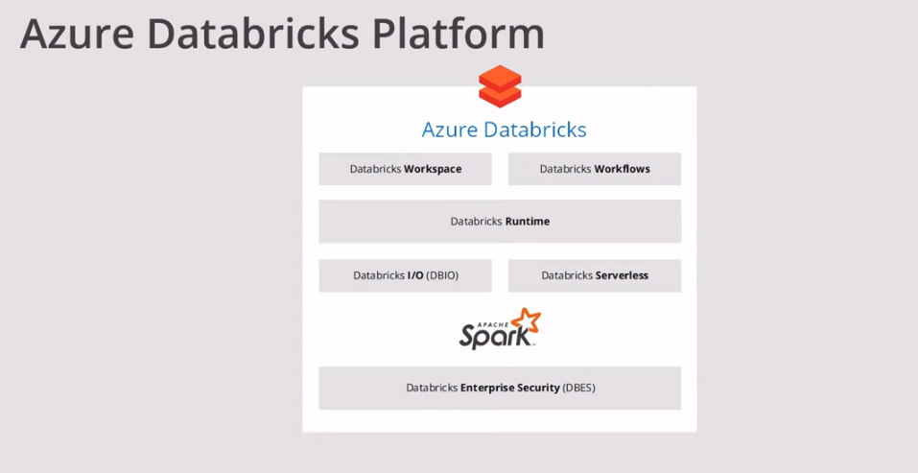

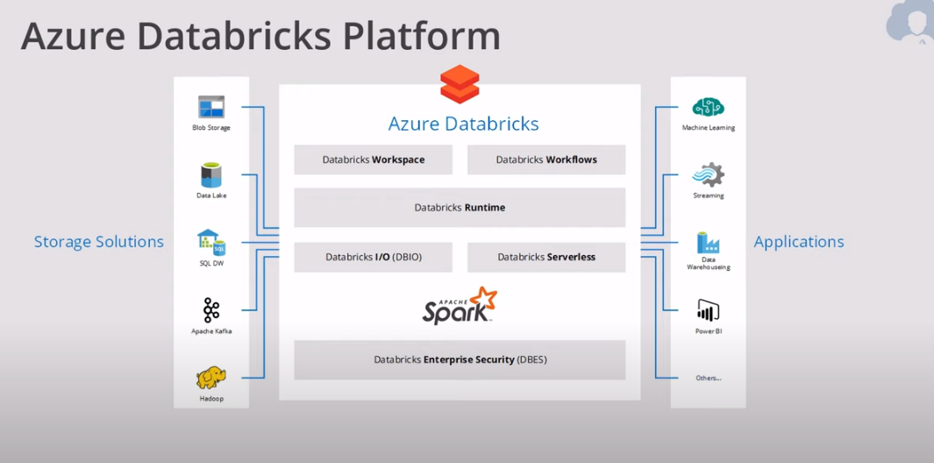

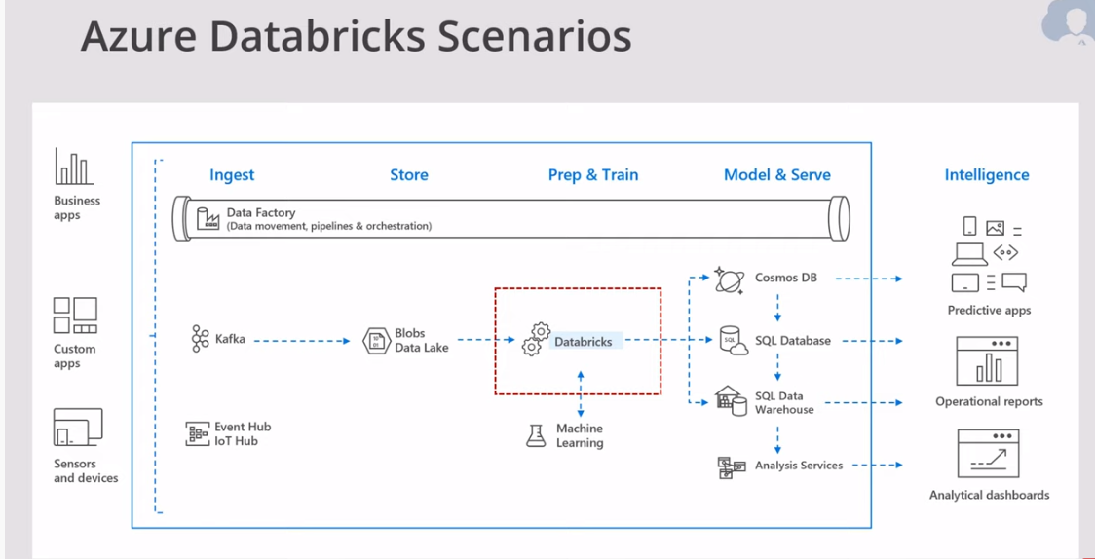

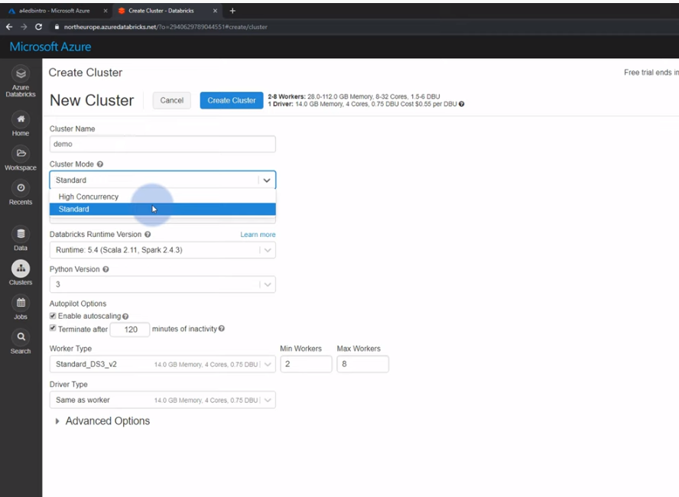

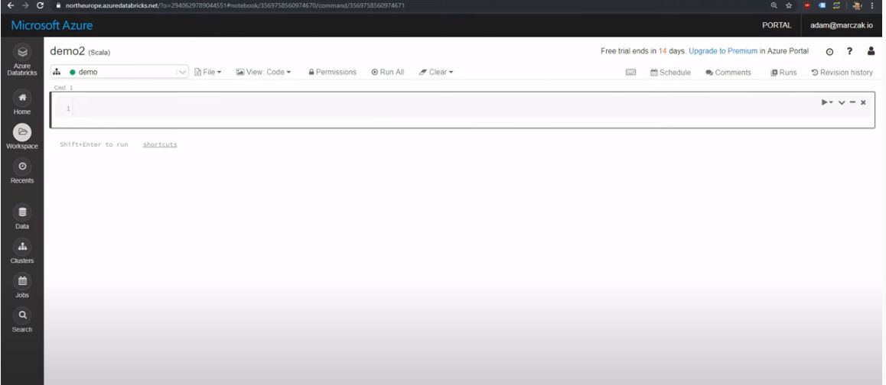

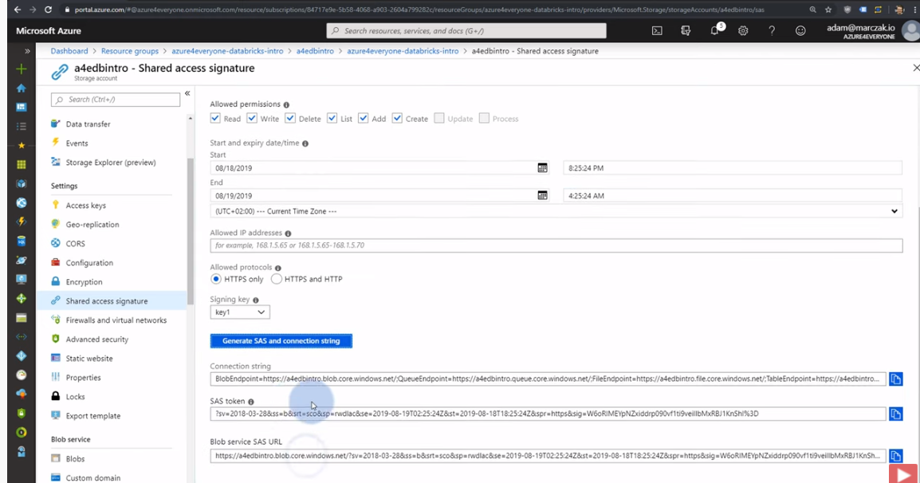

SAS token is important

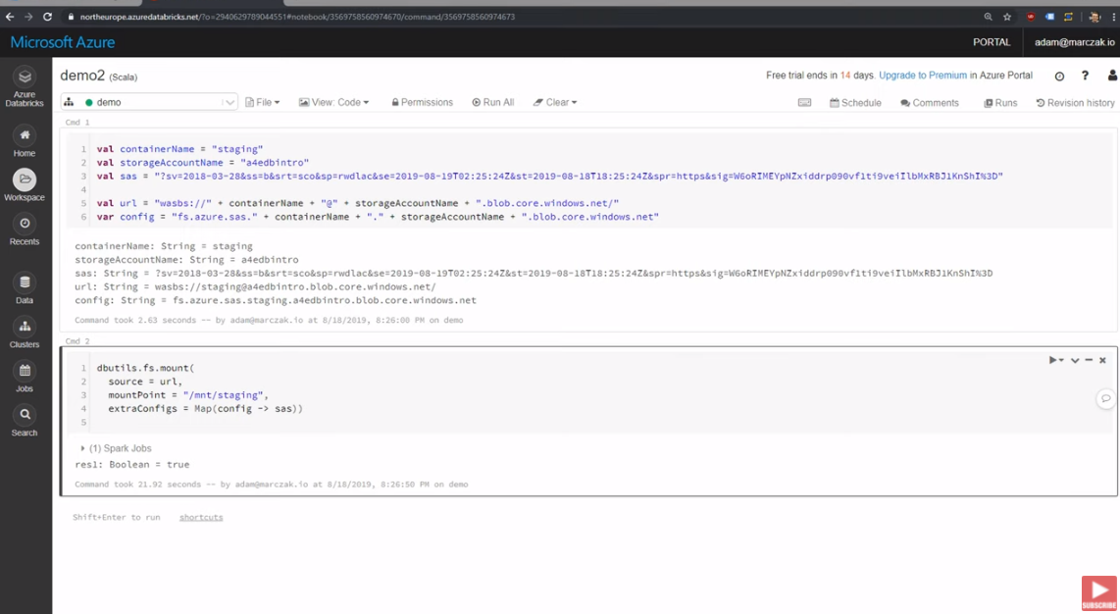

Mount and read file

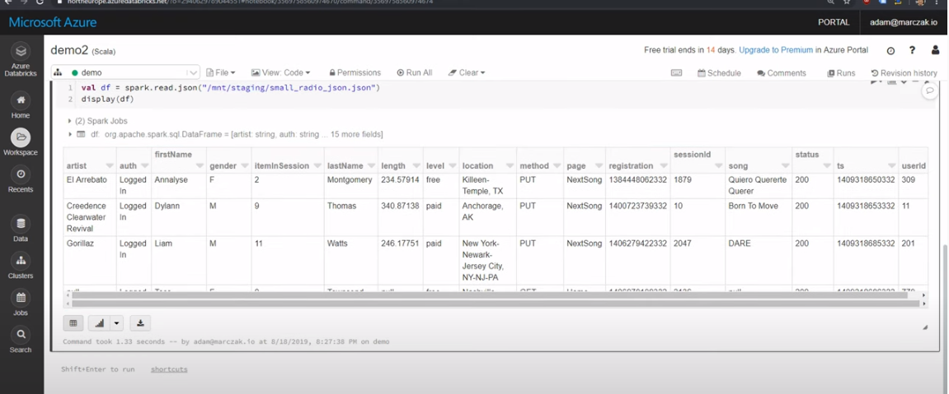

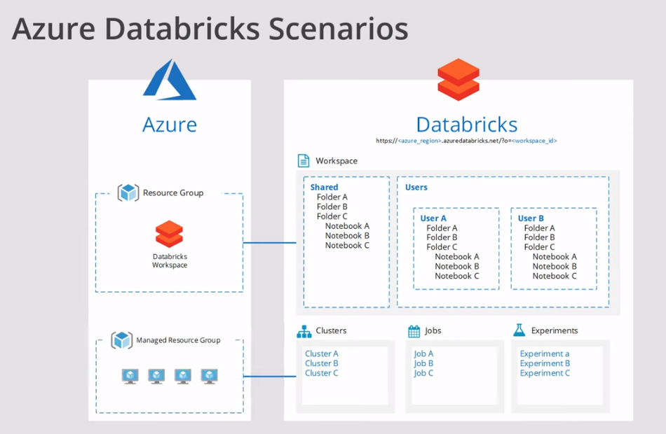

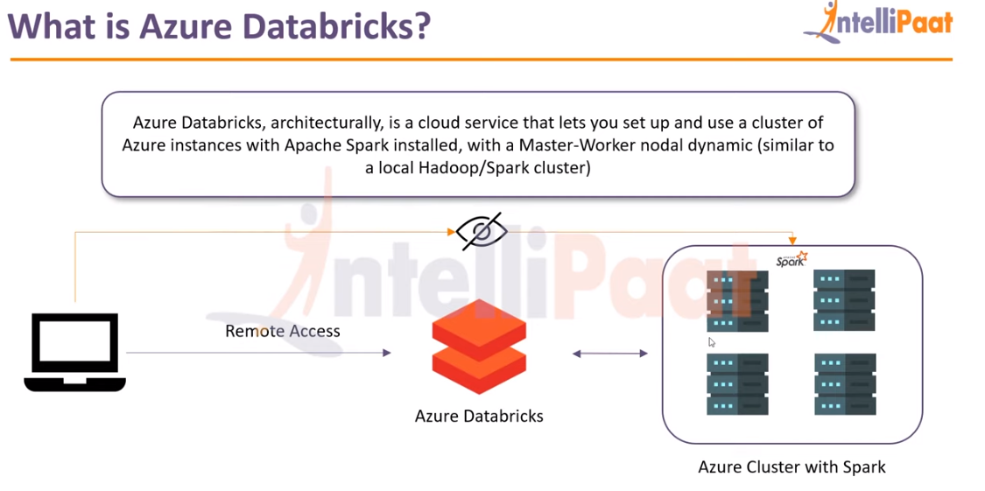

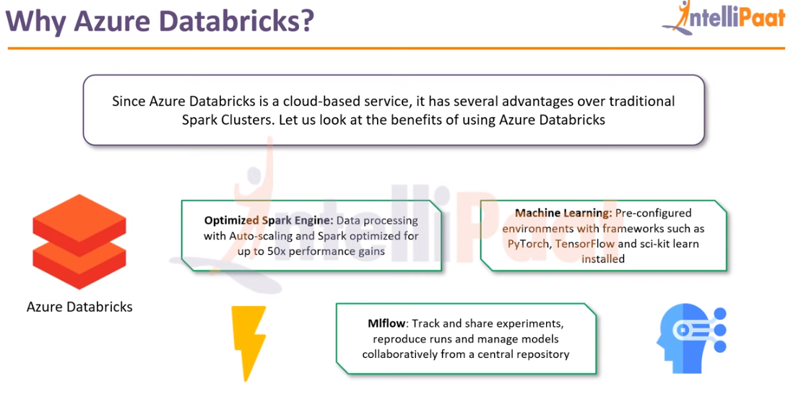

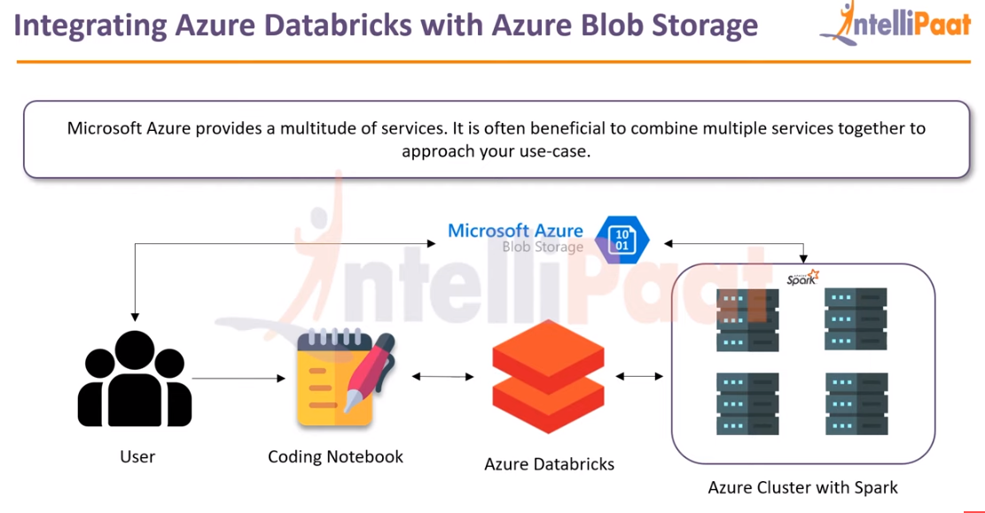

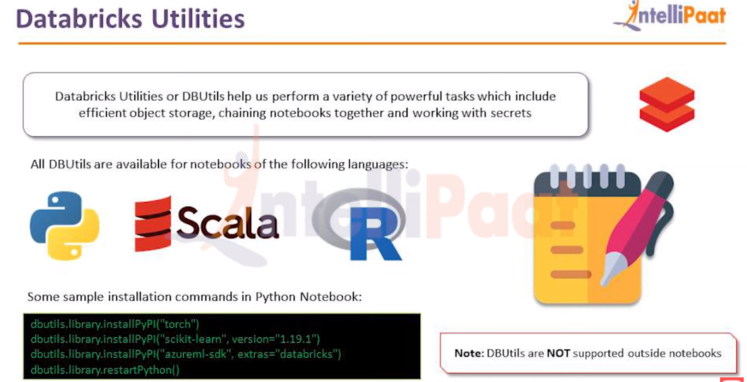

Data bricks and storage account should be in the same resource group.

1. Create azure data bricks service
2. Launch the workspace, login
3. We can create cluster, new notebook, create table, new job etc.
4. Create cluster with name, mode (standard/high concurrency), runtime, auto scaling, nodes, driver type, worker type etc. Once deployed you can see cluster in the interactive clusters.
5. New notebook, we can select language like python, Scala and cluster name to run.
6. We can integrate Azure blob storage or any other wit in Notebook.
7. No Hadoop HDFS required, its DBFS(cloud)
8. Data bricks and Blobs should be in the same resource group.
9. Shared Access Signature is important to access blobs from notebook
10. We can create notebooks without clusters and not charged.
11. To run the notebooks we need cluster.
12. Register the app and certificate and secrets, use key vault for storing secrets.
13. 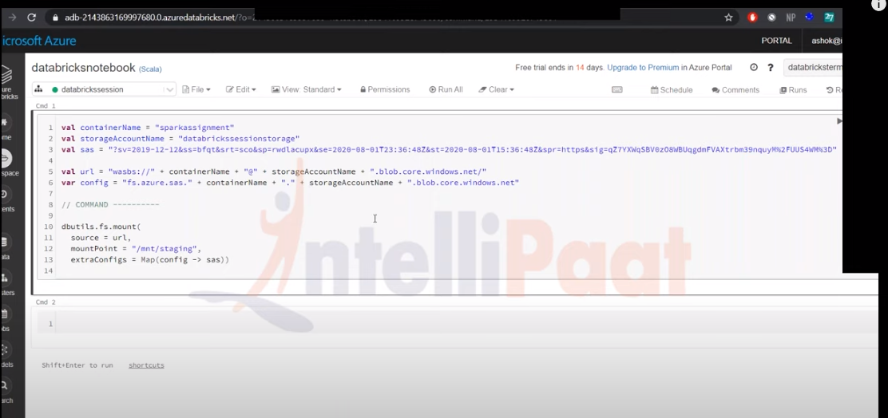
14. Port the blob container to the Data bricks spark cluster/server.

